Identifying the Main Idea

Lesson Objective
In this lesson, you will learn how to find the main idea in a short text. You will learn what the main idea is and where to look for it. You will also learn how to express it. First, let’s look at who creates the main idea.
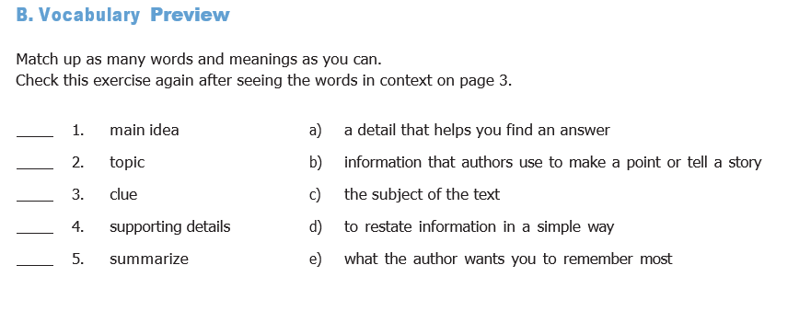
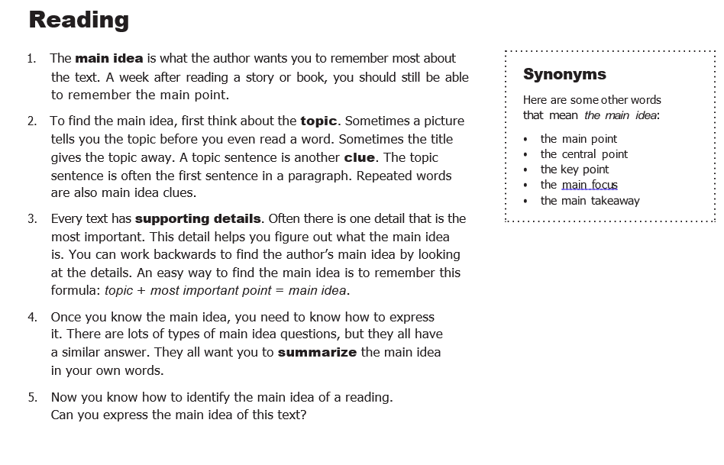
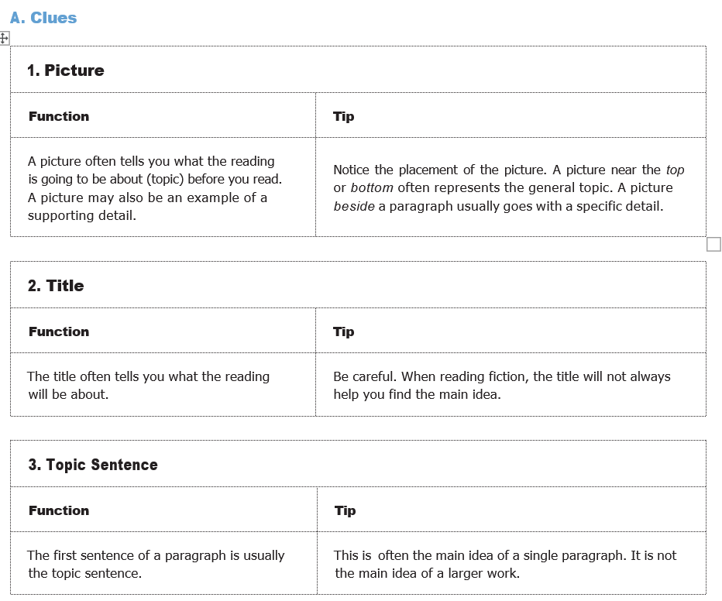
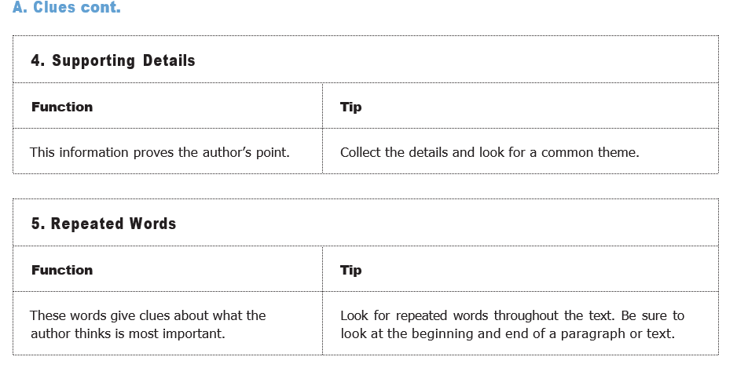
Activity 1
Based on the following reading, complete with the information that corresponds.
- Topic sentence
- Supporting details
- Picture (description)
- Title
- Vocabulary meaning and important or repeated words

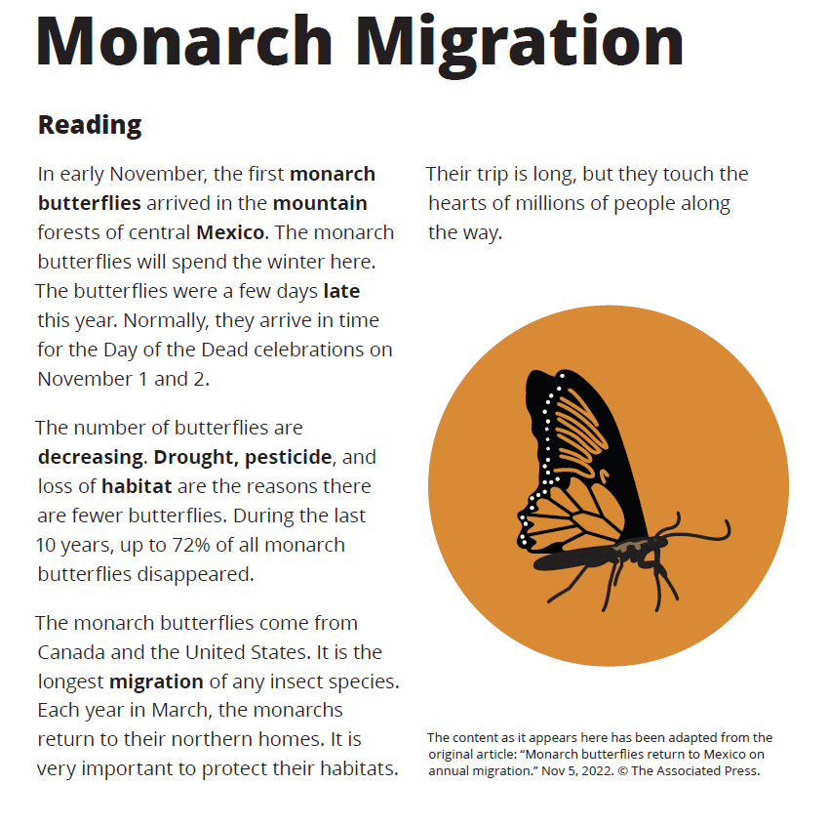

Activity 2
Answer the following questions based on the previous reading
- What is the story about?
- When do the butterflies arrive in Mexico?
- What Mexican celebration do the butterflies usually arrive for?
- What is true about the monarch butterfly population?
- When do the butterflies return to the north?
- What is special about the butterflies’ migration?
Activity 3
Read the text below. List any clue that helps you find the main idea. Compare your clues with a partner’s clues.
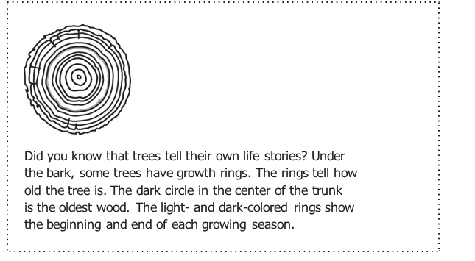
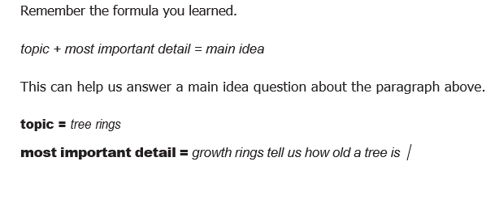
- What is the paragraph mainly about?

Activity 4
Read a related paragraph. Identify the main topic and the most important detail. Then answer the questions.
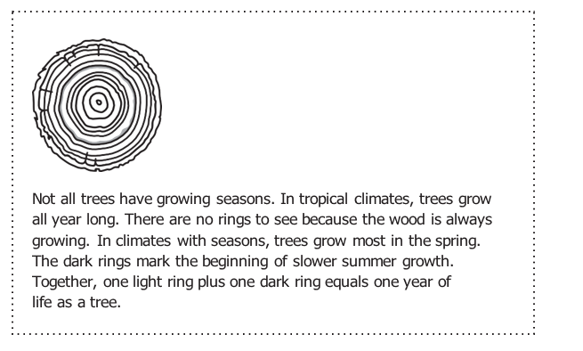
- What is the topic?
- What is the most important detail?
- What is the author’s main point?
Activity 5
Complete the sentences using the vocabulary from the first page
1. An author makes his or her point with several ________________ details.
2. The____________________ sentence is usually the first sentence in a paragraph.
3. A picture gives you a ____________________ about the topic before you read the text.
4. Write one sentence to the main idea in your own words.

Activity 6
Read the text and complete the chart
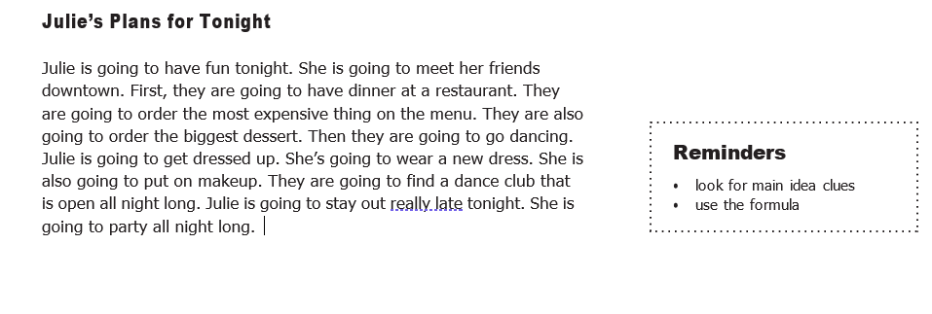
1 | Clues
2 | Topic
3 | Most important detail

- What is the main idea of the reading?
- What is the author’s main point?

